THE Mountain SPOKE

Aurthor: Kyle Petersen

# Website Planning Document

## Site Purpose

The purpose is to provide a fresh new website experience for Mountain Spoke’s clients and potential clients that reflects their culture of bicycle enthusiasm with products, repair service, parts, and tour trips.

## Target Audience

* Clients
* Potential clients

## Site Map

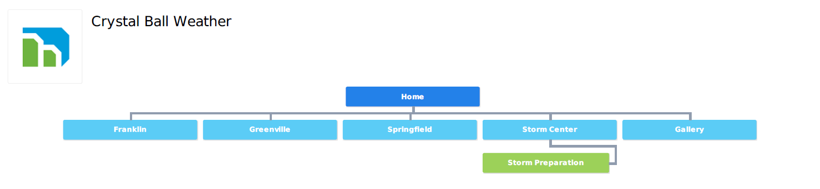

## Color Scheme

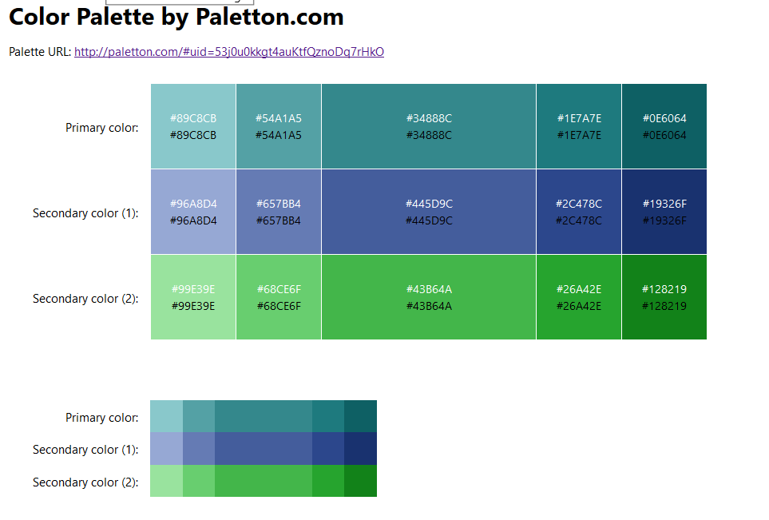

## Typography

|  |  |  |
| --- | --- | --- |
| Section | Typeface | Example |
| Site Header | Book Antique | Welcome |
| Header Navigation | Book Antique | Navigation |
| Footer Navigation | Book Antique | Navigation |
| Heading 1 (H1) | Book Antique | Header 1 |
| Header 2 (H2) | Book Antique | Header 2 |
| Header 3 (H3) | Book Antique | Header 3 |
| Body | Tahoma | Body typeface |